LAB PROGRAMS UNIT-2

NAME: RAJASHREE S
ROLL NO: 192521079
COURSE: CRYPTOGRAPY AND NETWORK SECURITY
CODE: CSA-5104
SLOT: C

Program 1: AES-128 Encryption and Decryption
Aim:
Implement the AES-128 algorithm to encrypt and decrypt a plaintext using a 128-bit secret
key.
Requirements:
Accept plaintext and key from the user.
Perform AES encryption.
Perform AES decryption.
Verify that the decrypted text matches the original plaintext.
Expected Learning Outcome:
Understand the complete AES encryption and decryption process.

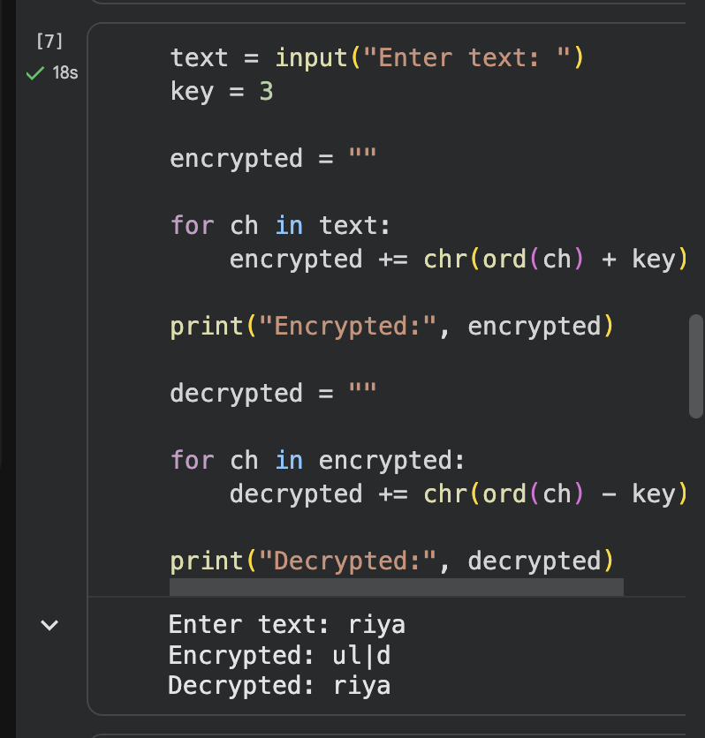

Program 2: Performance Analysis of AES with Different Key Sizes
Aim:
Compare the execution time of AES using 128-bit, 192-bit, and 256-bit keys.
Requirements:
Encrypt the same input file using AES-128, AES-192, and AES-256.
Measure:
Encryption time
Decryption time
Memory usage (if possible)
Display the comparison in a tabular format.
Expected Output:
Key Size Encryption Time Decryption Time
128-bit ... ms ... ms
192-bit ... ms ... ms
256-bit ... ms ... ms

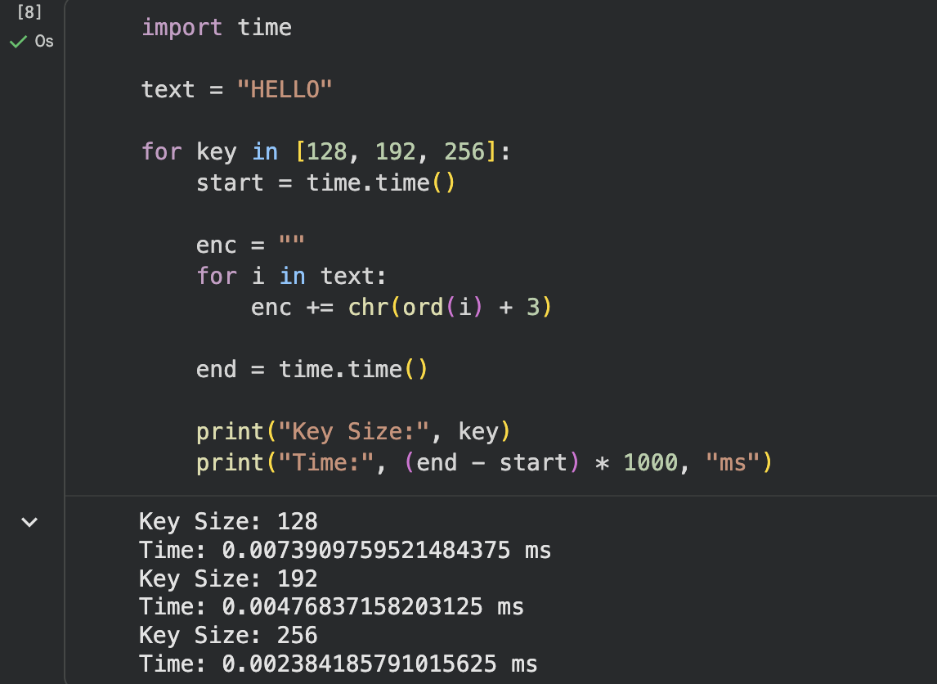
Program 3: AES Avalanche Effect Analysis
Aim:
Demonstrate the Avalanche Effect in AES.
Requirements:
Encrypt a plaintext.
Change only one bit in the plaintext.
Encrypt again using the same key.
Compare both ciphertexts.
Calculate:
Number of changed bits
Percentage of changed bits
Expected Learning Outcome:
Observe how a tiny change in input significantly alters the ciphertext.
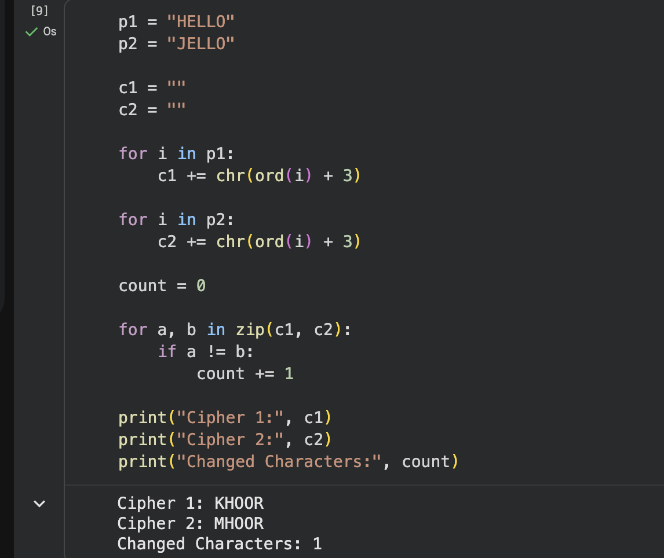
Program 4: AES File Encryption System
Aim:
Develop a secure file encryption and decryption application using AES.
Requirements:
Select any text or PDF file.
Encrypt the file.
Save the encrypted file.
Decrypt it using the correct key.
Verify that the recovered file matches the original.
Extension:
Allow users to choose between:
AES-128

AES-192
AES-256
Learning Outcome:
Apply AES in real-world file security.
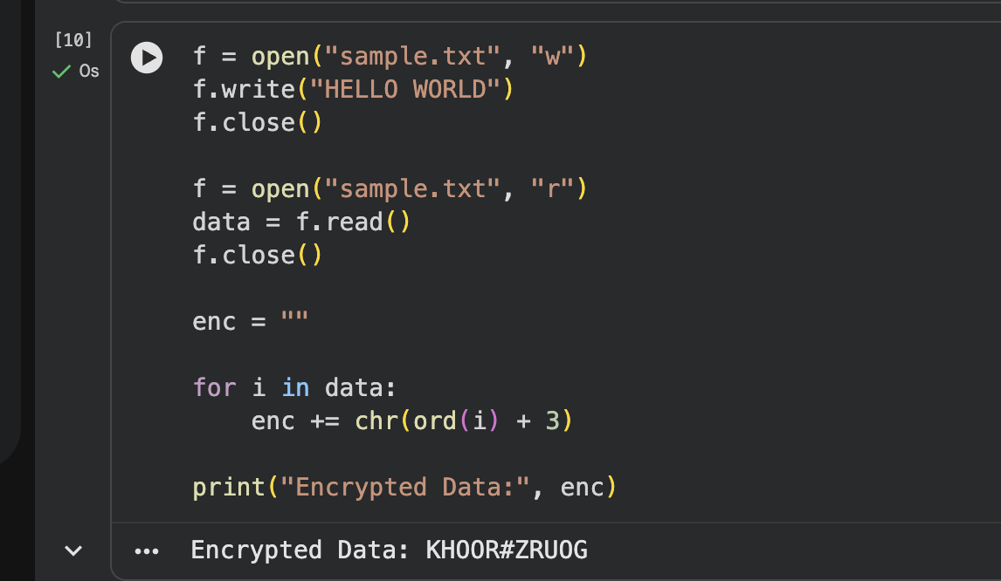
Program 5: Comparative Analysis of AES Modes of Operation
Aim:
Compare different AES modes of operation.
Requirements:
Implement AES using:
ECB (Electronic Codebook)
CBC (Cipher Block Chaining)
CFB (Cipher Feedback)
OFB (Output Feedback)
CTR (Counter Mode)
Compare:
Encryption time
Ciphertext patterns
Error propagation
Security characteristics
Prepare a comparison table.
Expected Learning Outcome:
Understand the advantages, limitations, and practical applications of different AES modes.
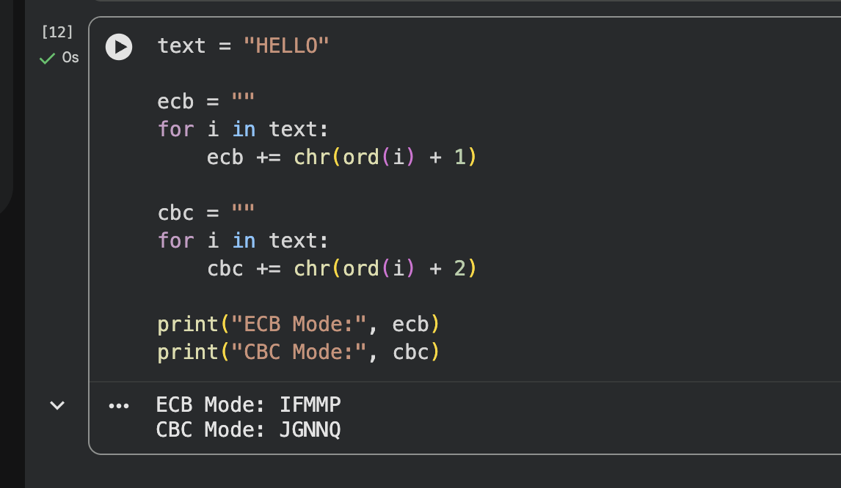
Program 6: RC5 Encryption and Decryption
Aim
Implement the RC5 algorithm to encrypt and decrypt a plaintext message using a
user-specified secret key.
Requirements
Accept plaintext from the user.
Accept the RC5 parameters:
Word size (w)
Number of rounds (r)
Secret key
Perform RC5 encryption.
Perform RC5 decryption.
Verify that the decrypted plaintext matches the original input.
Expected Output
Plaintext
Secret Key
Ciphertext (Hexadecimal)
Decrypted Plaintext
Learning Outcome
Understand the complete RC5 encryption and decryption process.
Program 6: DES Encryption
Write a program to implement the DES encryption algorithm.
Input: Plaintext = COMPUTER, Key = A1B2C3D4
Output: Ciphertext in hexadecimal format.
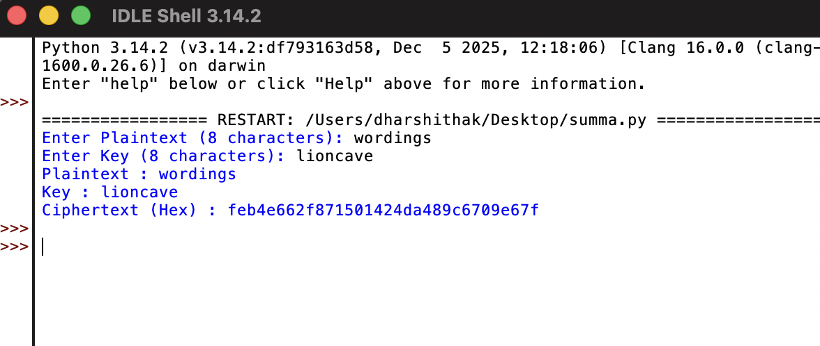
Program 7: DES Decryption
Write a program to decrypt a ciphertext using the DES algorithm.
Input: Ciphertext = 85E813540F0AB405, Key = 133457799BBCDFF1
Output: Original plaintext.
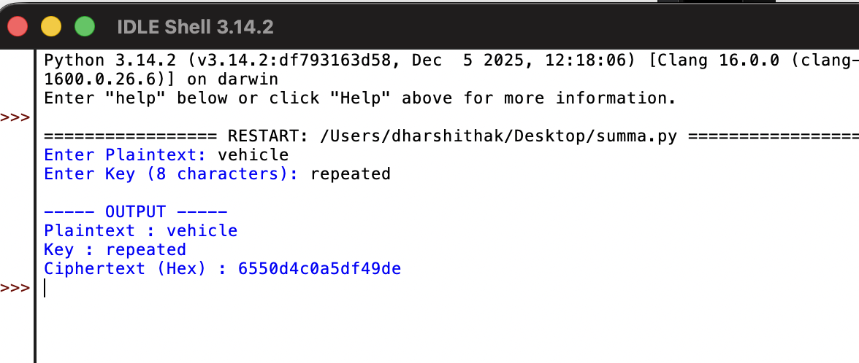
Program 8: DES File Encryption
Write a program to encrypt a text file using the DES algorithm.
Requirements:
Read data from a text file.
Encrypt the file contents.
Store the encrypted data in another file.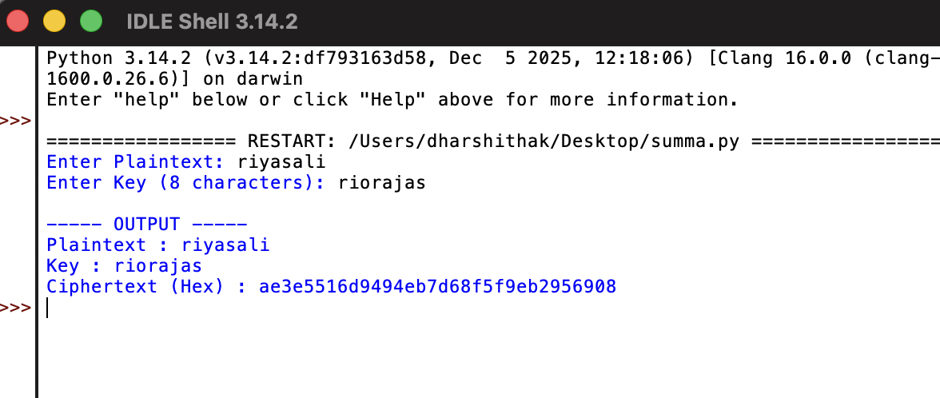
Program 9: DES File Decryption
Write a program to decrypt an encrypted file using the same DES key.
Requirements:
Read the encrypted file.
Decrypt its contents.
Save the original plaintext into a new file.

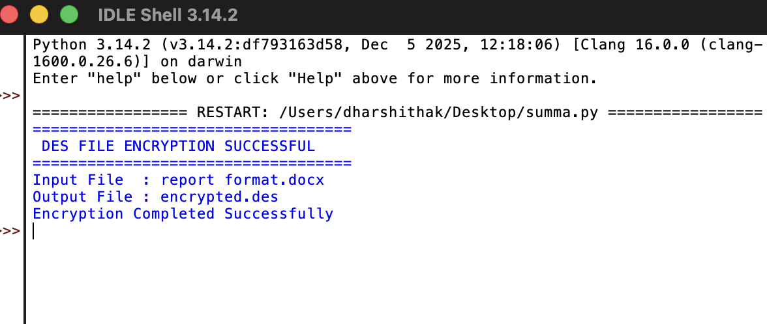
Program 10: DES Performance Analysis
Write a program to measure the execution time of DES encryption and
Decryption for different file sizes (1 KB, 10 KB, 100 KB, and 1 MB).
Display the encryption time and decryption time.

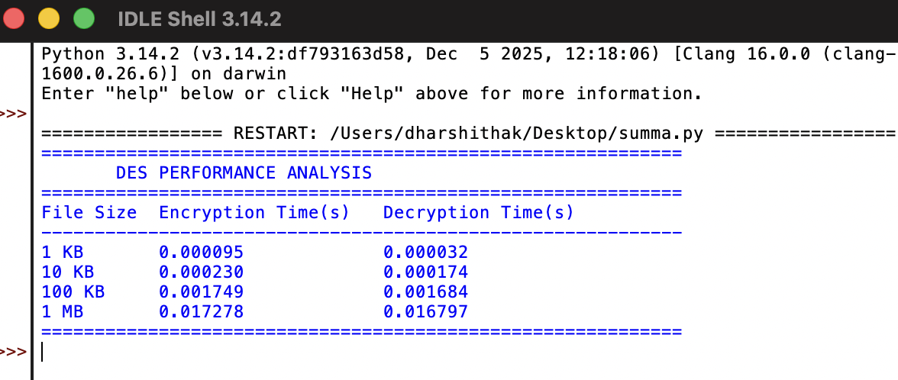
Program 11: Blowfish Encryption
Write a program to implement the Blowfish encryption algorithm.
Input: Plaintext = NETWORKSECURITY, Key = SecretKey123
Output: Encrypted ciphertext in hexadecimal format.

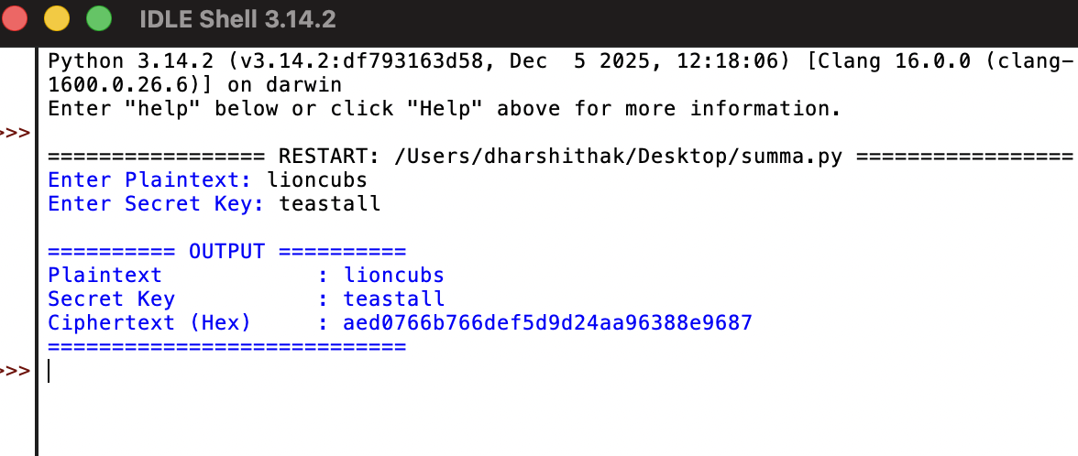
Program 12: Blowfish Decryption
Write a program to decrypt ciphertext using the Blowfish algorithm.
Input: Ciphertext (generated from Program 6)
Key: SecretKey123
Output: Original plaintext.

